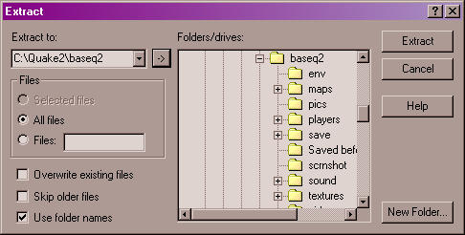

This is how your window should look when extracting the zip file.

Notice:
1 The “Extract to” is pointing to C:\Quake2\baseq2
2 “All files” is checked
3 “Use folder names” is checked (THIS IS VERY IMPORTANT)
4 Now hit “Extract” on the upper right
5 You should be able to run the map at this point

